SQL Query and Subquery

1-Query

✅ What is a Query in SQL?
# Source: AI Source: Provided by: [Data Path: Persons Table -> ID Column: 1, Name_En Column: Motasem Essam] -> From: [ChatGPT] on [6/11/2026]
A query is a request to access or manipulate data in a database using SQL (Structured Query Language).
It tells the database what data you want, how you want it, or what changes to make.

🔍 Types of SQL Queries
# Source: AI Source: Provided by: [Data Path: Persons Table -> ID Column: 1, Name_En Column: Motasem Essam] -> From: [ChatGPT] on [6/11/2026]
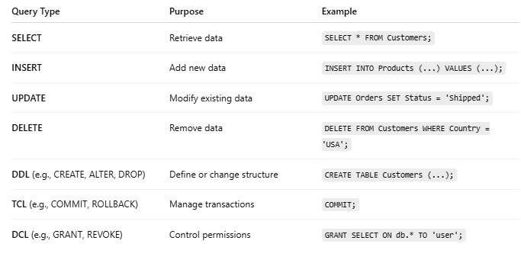
Query Type | Purpose | Example
SELECT | Retrieve data | SELECT * FROM Customers;
INSERT | Add new data | INSERT INTO Products (...) VALUES (...);
UPDATE | Modify existing data | UPDATE Orders SET Status = 'Shipped';
DELETE | Remove data | DELETE FROM Customers WHERE Country = 'USA';
DDL (e.g., CREATE, ALTER, DROP) | Define or change structure | CREATE TABLE Customers (...);
TCL (e.g., COMMIT, ROLLBACK) | Manage transactions | COMMIT;
DCL (e.g., GRANT, REVOKE) | Control permissions | GRANT SELECT ON db.* TO 'user';

🧠 Query Structure (For SELECT):
# Source: AI Source: Provided by: [Data Path: Persons Table -> ID Column: 1, Name_En Column: Motasem Essam] -> From: [ChatGPT] on [6/11/2026]
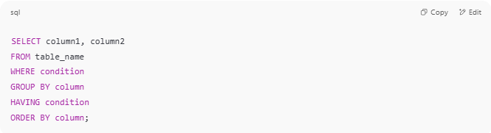
SELECT column1, column2
FROM table_name
WHERE condition
GROUP BY column
HAVING condition
ORDER BY column;

📌 Example:
# Source: AI Source: Provided by: [Data Path: Persons Table -> ID Column: 1, Name_En Column: Motasem Essam] -> From: [ChatGPT] on [6/11/2026]
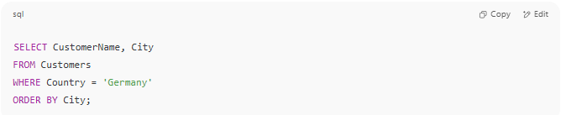
SELECT CustomerName, City
FROM Customers
WHERE Country = 'Germany'
ORDER BY City;

🔸 This query asks:
"Give me names and cities of customers from Germany, ordered by city."

📘 Summary:
# Source: AI Source: Provided by: [Data Path: Persons Table -> ID Column: 1, Name_En Column: Motasem Essam] -> From: [ChatGPT] on [6/11/2026]
- A query is the way to ask questions or give commands to a database.
- It can retrieve, insert, update, delete, or define data.
- SQL = Query Language, and every command you write in SQL is a query.
Would you like to test some queries live or get practice exercises?

2-Subquery

✅ What is a Subquery in SQL?
# Source: AI Source: Provided by: [Data Path: Persons Table -> ID Column: 1, Name_En Column: Motasem Essam] -> From: [ChatGPT] on [6/11/2026]
A subquery (also called an inner query or nested query) is a query inside another SQL query.
It returns data that the main (outer) query can use in its conditions or result set.

🔍 Example — Subquery in WHERE clause
# Source: AI Source: Provided by: [Data Path: Persons Table -> ID Column: 1, Name_En Column: Motasem Essam] -> From: [ChatGPT] on [6/11/2026]
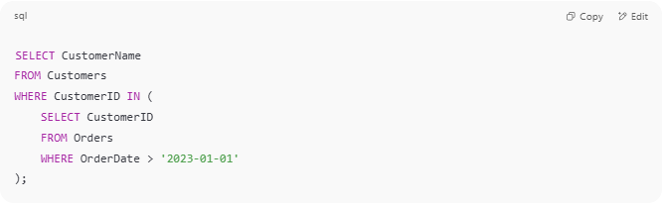
SELECT CustomerName
FROM Customers
WHERE CustomerID IN (
SELECT CustomerID
FROM Orders
WHERE OrderDate > '2023-01-01'
);

🟡 Explanation:
- The subquery: SELECT CustomerID FROM Orders ...
- It runs first and returns customer IDs.
- The outer query: selects names of those customers.

🧩 Where Can Subqueries Be Used?
# Source: AI Source: Provided by: [Data Path: Persons Table -> ID Column: 1, Name_En Column: Motasem Essam] -> From: [ChatGPT] on [6/11/2026]
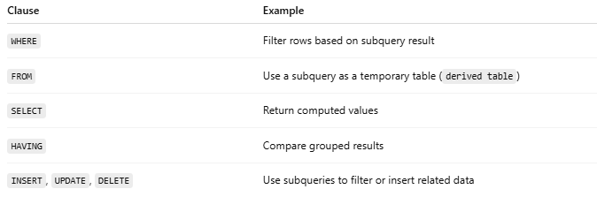
Clause | Example
WHERE | Filter rows based on subquery result
FROM | Use a subquery as a temporary table (derived table)
SELECT | Return computed values
HAVING | Compare grouped results
INSERT, UPDATE, DELETE | Use subqueries to filter or insert related data

🔄 Types of Subqueries
# Source: AI Source: Provided by: [Data Path: Persons Table -> ID Column: 1, Name_En Column: Motasem Essam] -> From: [ChatGPT] on [6/11/2026]
- Scalar subquery → returns single value
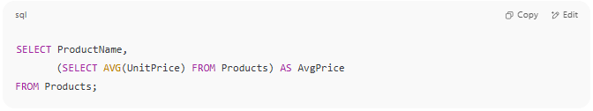
SELECT ProductName,
(SELECT AVG(UnitPrice) FROM Products) AS AvgPrice
FROM Products;

- Column subquery → returns one column, many rows
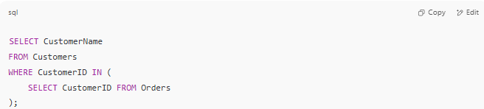
SELECT CustomerName
FROM Customers
WHERE CustomerID IN (
SELECT CustomerID FROM Orders
);

- Row subquery → returns one full row

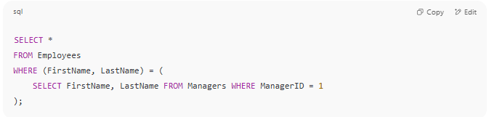
SELECT *
FROM Employees
WHERE (FirstName, LastName) = (
SELECT FirstName, LastName FROM Managers WHERE ManagerID = 1
);

- Correlated subquery → references the outer query
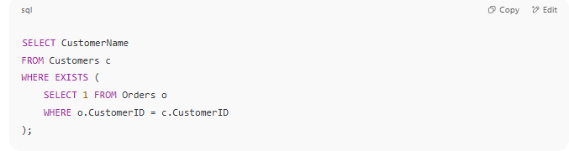
SELECT CustomerName
FROM Customers c
WHERE EXISTS (
SELECT 1 FROM Orders o
WHERE o.CustomerID = c.CustomerID
);

⚠️ Subquery vs JOIN?
# Source: AI Source: Provided by: [Data Path: Persons Table -> ID Column: 1, Name_En Column: Motasem Essam] -> From: [ChatGPT] on [6/11/2026]
- Use JOIN when you want to combine data.
- Use subquery when you want to filter or compute values based on another table.

